Streaker Project

Hello there Paul,
Thanks for the Streaker that you send to us. Sorry for taking such a long time to reply to you on the progress of the models that we’ve made. We’ve been really busy in Singapore.

Anyway here are some of the pictures that we’ve took during our 1st test flight of the Streaker model.
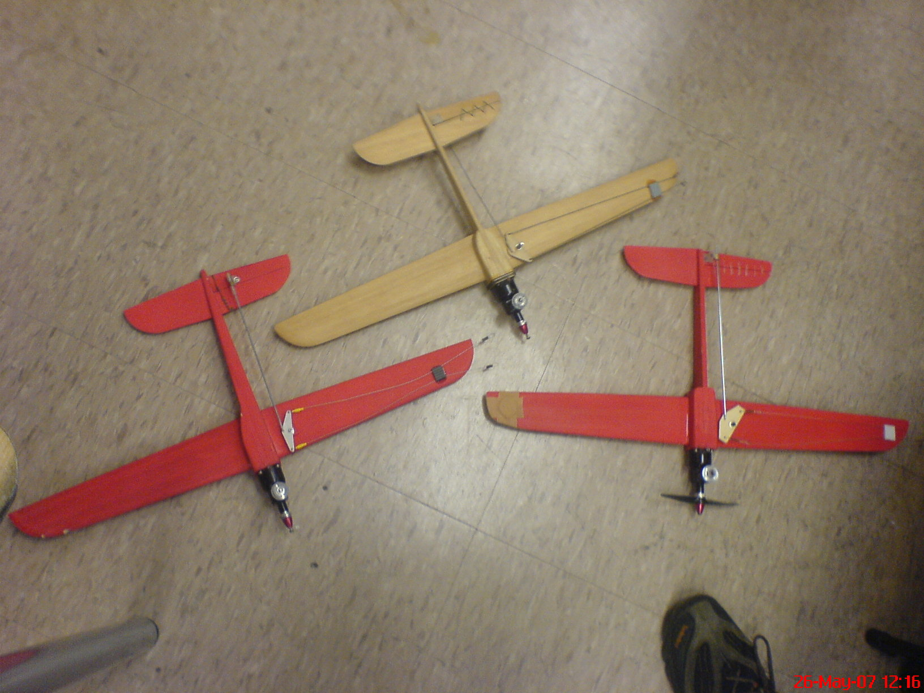

A total of 3 models were built.
Original template is the unsprayed model.
2 other prototype models were built from balsa wood. Extremely light weight and easy to fly.

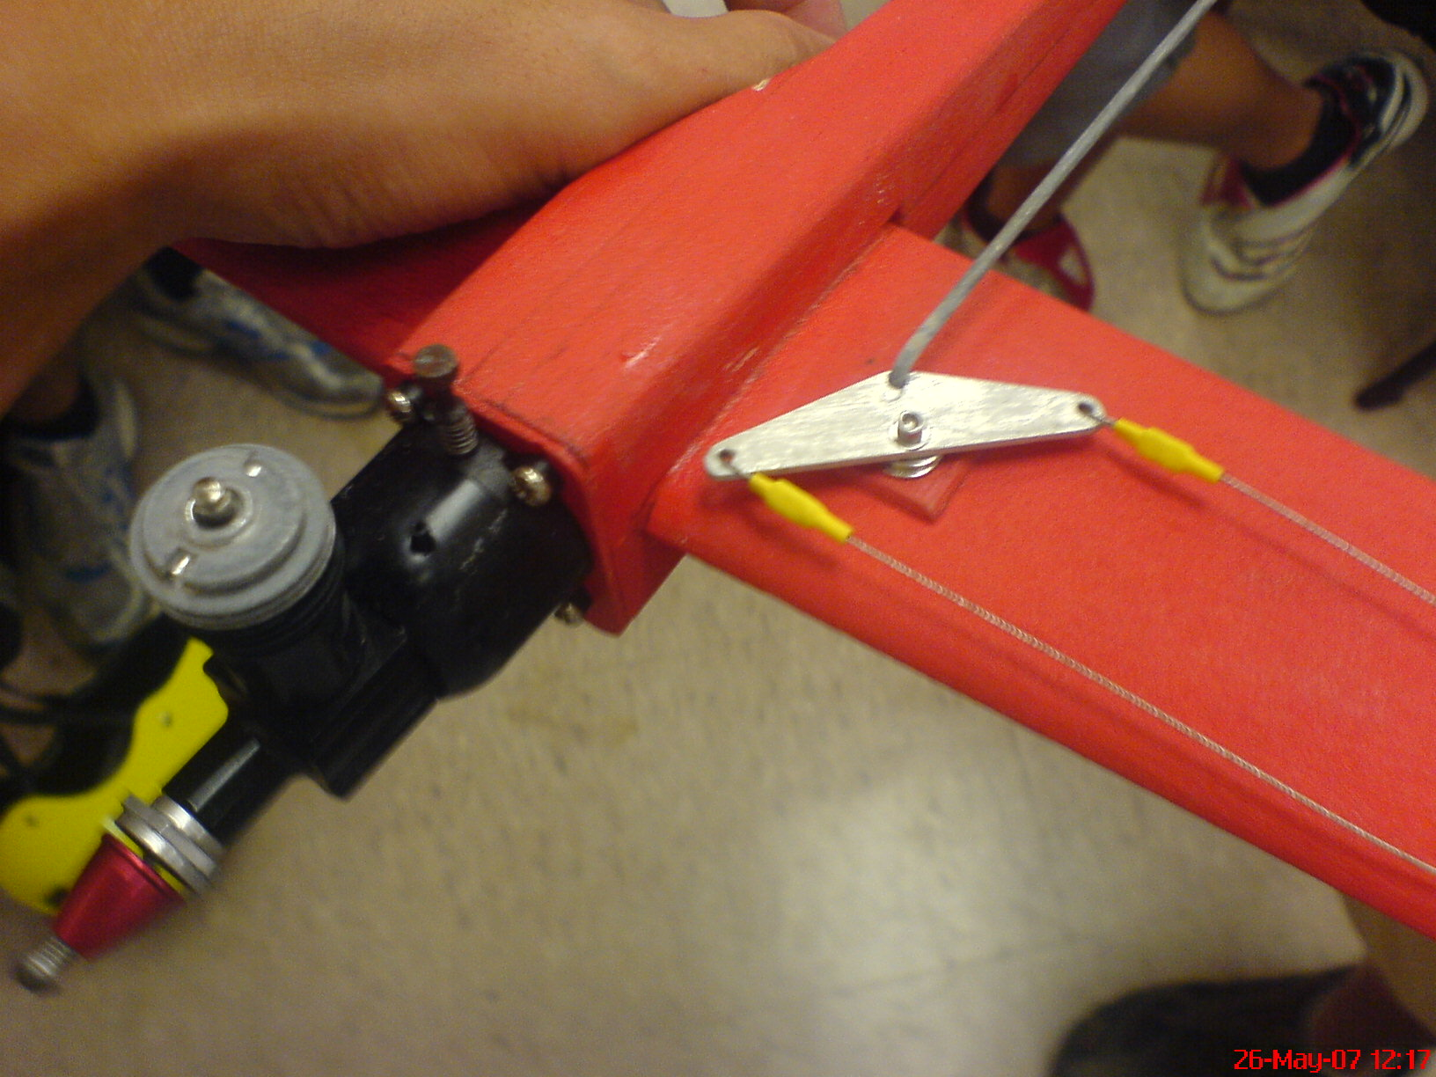

The model runs on a 0.49 COX engine.
It runs on standard glow fuel with 10% -30% nitro.

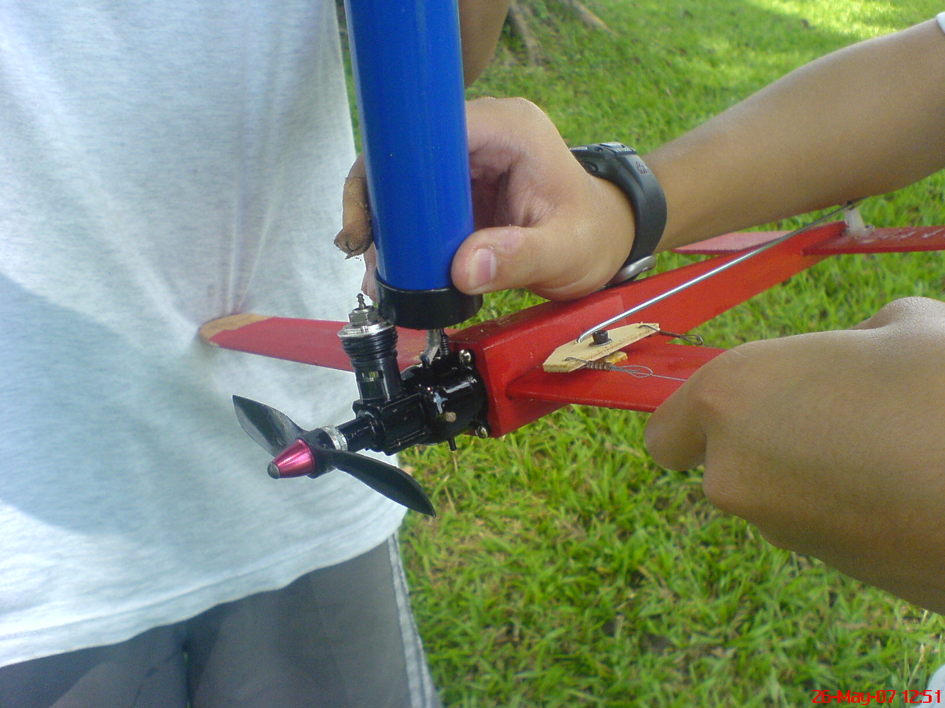

The built in tank acts as a mount for the engine, relatively easy to refuel.

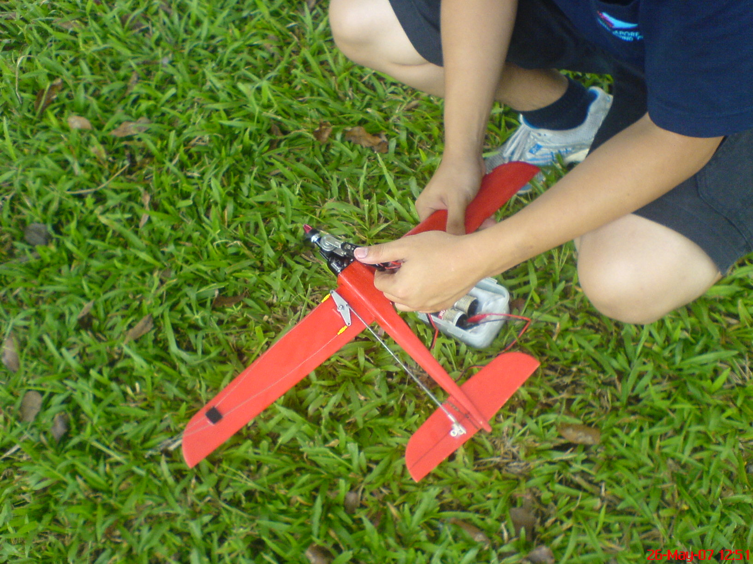

The engine was extremely easy to start. It almost always starts with a single flick.

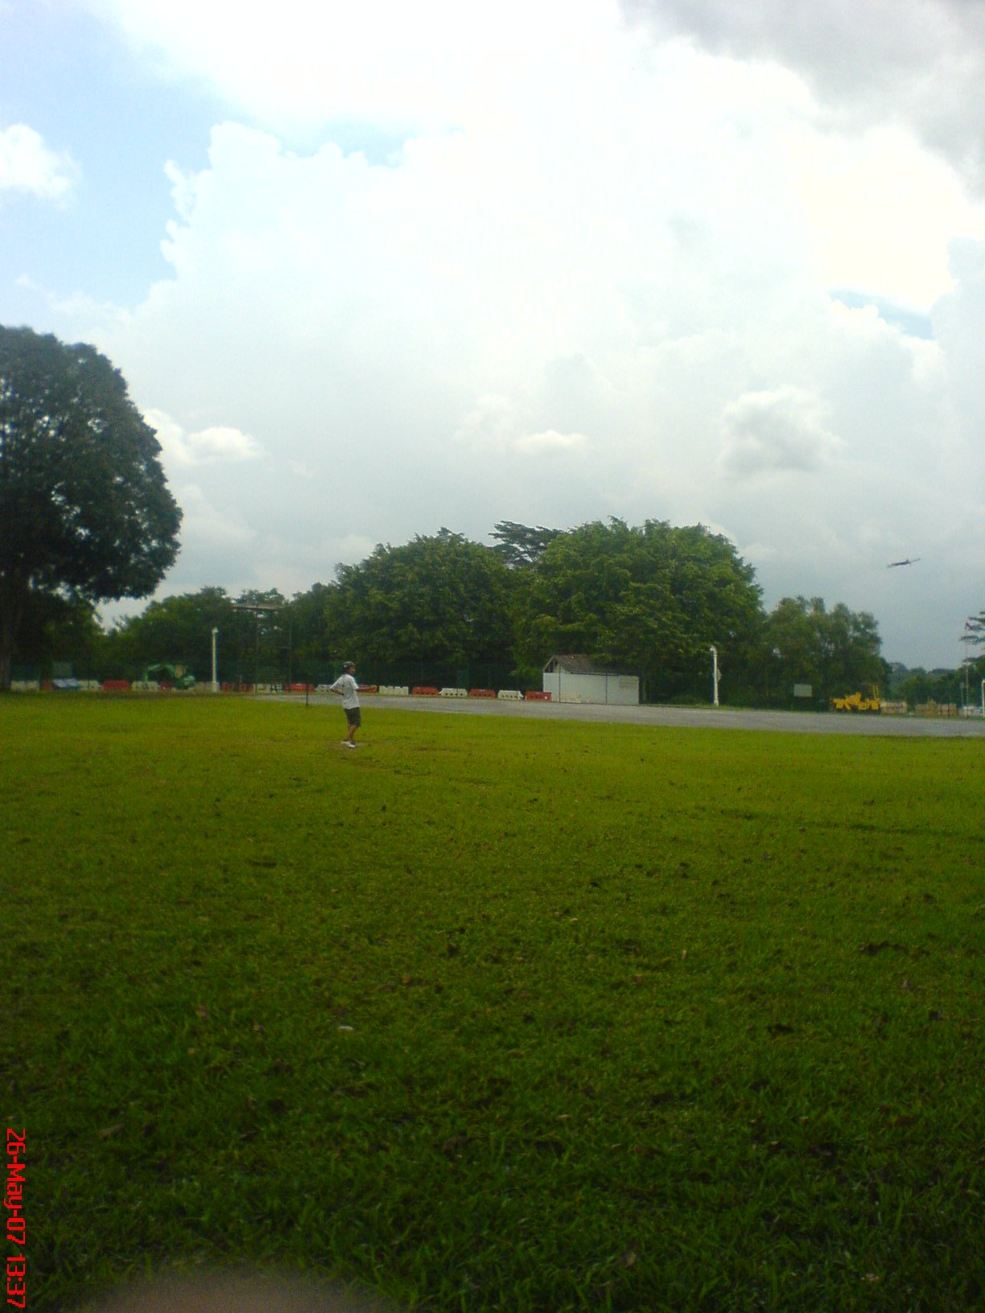
1st test flight
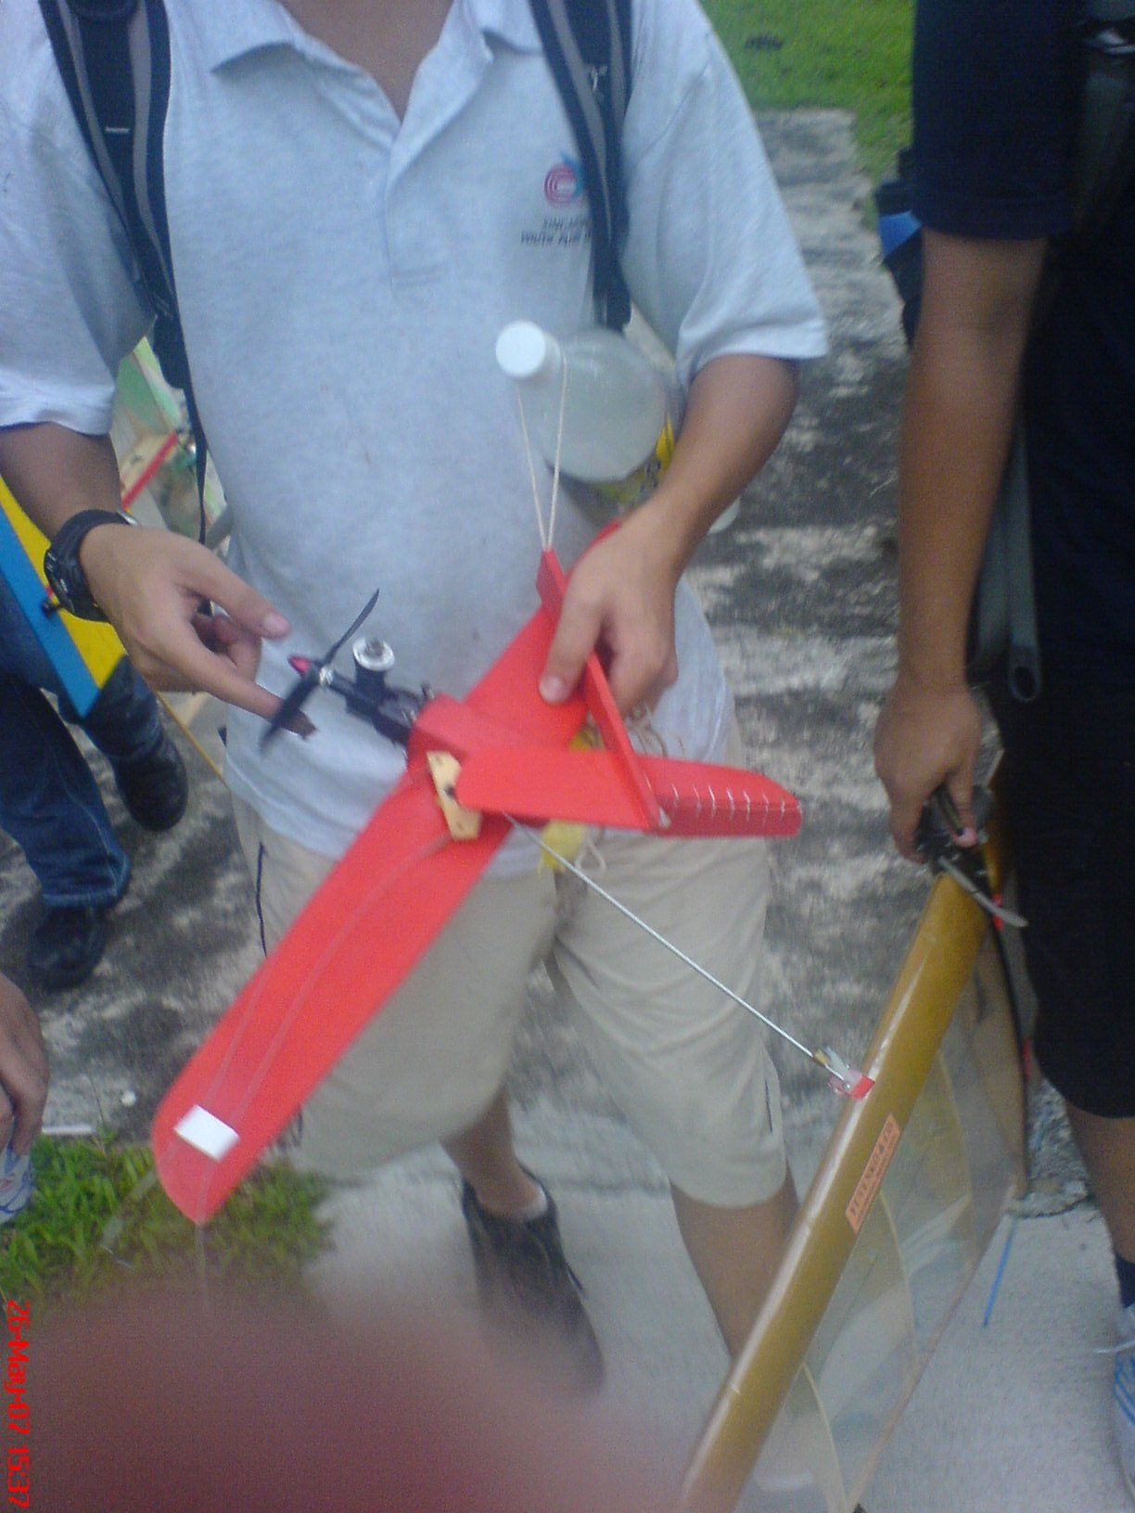
The model was very stable, even in windy condition.
However the prototype balsa model weren’t very hardy. →

Overall we had a great time flying the Streaker.
Thank you once again for your kind gesture. =)

Done By: Christopher Wong

